# Module 5 – Data Visualisation

**Day 1, Activity 1 🡪 Exponential Chart**

# Import Numpy for calculations and matplotlib for charting

import numpy as np

import matplotlib.pyplot as plt

# Creates a numpy array from 0 to 5 with each step being 0.1 higher than the last

x_axis = np.arange(0, 5, 0.1)

x_axis

# Creates an exponential series of values which we can then chart

e_x = [np.exp(x) for x in x_axis]

e_x

# Create a graph based upon the list and array we have created

plt.plot(x_axis, e_x)

# Show the graph that we have created

plt.show()

# Give our graph axis labels

plt.xlabel("Time With MatPlotLib")

plt.ylabel("How Cool MatPlotLib Seems")

# Have to plot our chart once again as it doesn't stick after being shown

plt.plot(x_axis, e_x)

plt.show()



**Day 1, Activity 1 🡪 sin_cos**

# Import Numpy for calculations and matplotlib for charting

import numpy as np

import matplotlib.pyplot as plt

# Create our x_axis numpy array

x_axis = np.arange(0, 6, 0.1)

# Creates a numpy array based on the sin of our x_axis values

sin = np.sin(x_axis)

# Creates a numpy array based on the cos of our x_axis values

cos = np.cos(x_axis)

# Plot both of these lines so that they will appear on our final chart

plt.plot(x_axis, sin)

plt.plot(x_axis, cos)

plt.show()

**Day 1, Activity 2 🡪 Melb Temperature**

# Set x axis to numerical value for month

x_axis_data = np.arange(1,13,2)

x_axis_data



# Average weather temp

points = [26.1, 25.3, 22.5, 20.6, 17.3, 14.5, 13.5, 15.8, 17.9, 19.2, 20.3, 24.7]

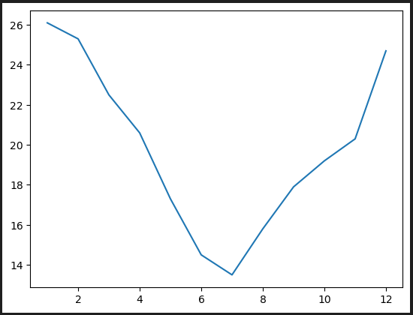

# Plot the line

plt.plot(x_axis_data, points)

plt.show()

# Convert to Fahrenheit F = C * 9/5 + 32

points_F = [round(x * 9 / 5 + 32,1) for x in points]

****points_F

# Plot using Fahrenheit

plt.plot(x_axis_data, points_F)

plt.show()



# Plot both on the same chart

plt.plot(x_axis_data, points)

plt.plot(x_axis_data, points_F)

plt.show()

**Day 1, Activity 3 🡪 Line Config**

# Dependencies

import matplotlib.pyplot as plt

import numpy as np

# Set x axis and variables

x_axis = np.arange(0, 10, 0.1)

sin = np.sin(x_axis)

cos = np.cos(x_axis)

# Draw a horizontal line with 0.25 transparency

plt.hlines(0, 0, 10, alpha=0.25)

# Assign plots to tuples that stores result of plot

# Each point on the sine chart is marked by a blue circle

sine_handle, = plt.plot(x_axis, sin, marker='o', color='blue', label="Sine")

# Each point on the cosine chart is marked by a red triangle

cosine_handle, = plt.plot(x_axis, cos, marker='^', color='red', label="Cosine")

plt.show()

# Adds a legend and sets its location to the lower right

plt.legend(loc="lower right")

plt.show()

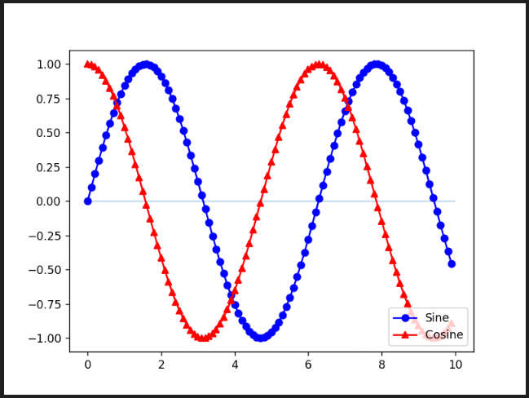

# Saves an image of our chart so that we can view it in a folder

plt.savefig("../Images/lineConfig.png")

plt.show()

**Day 1, Activity 4 🡪 Legendary Temp**

# Include this line to make plots interactive

%matplotlib widget

# Dependencies

import matplotlib.pyplot as plt

import numpy as np

# Set x axis to numerical value for month

x_axis = np.arange(1,13,1)

x_axis



# Avearge weather temp

points_C = [26.1, 25.3, 22.5, 20.6, 17.3, 14.5, 13.5, 15.8, 17.9, 19.2, 20.3, 24.7]

# Convert to Fahrenheit F = C * 9/5 + 32

points_F = [round(x * 9 / 5 + 32,1) for x in points_C]

points_F



# Create a handle for each plot

celsius, = plt.plot(x_axis, points_C, marker="s", color="Red", linewidth=1, label="Celsius")

fahrenheit, = plt.plot(x_axis, points_F, marker="+",color="blue", linewidth=1, label="Fahrenheit")

plt.show()

# Set our legend to where the chart thinks is best

plt.legend(handles=[celsius, fahrenheit], loc="best")

plt.show()

# Create labels for the X and Y axis

plt.xlabel("Months")

plt.ylabel("Degrees")

plt.show()

# Save and display the chart

plt.savefig("../Images/avg_temp.png")

plt.show()

**Day 1, Activity 5 🡪 Aesthetics**

# Dependencies

import matplotlib.pyplot as plt

import numpy as np

# Generate the x values from 0 to 10 using a step of 0.1

x_axis = np.arange(0, 10, 0.1)

sin = np.sin(x_axis)

cos = np.cos(x_axis)

# Add a semi-transparent horizontal line at y = 0

plt.hlines(0, 0, 10, alpha=0.25)

plt.show()

# Use dots or other markers for your plots, and change their colors

plt.plot(x_axis, sin, linewidth=0, marker="o", color="blue")

plt.plot(x_axis, cos, linewidth=0, marker="^", color="red")

plt.show()

# Add labels to the x and y axes

plt.title("Juxtaposed Sine and Cosine Curves")

plt.xlabel("Input (Sampled Real Numbers from 0 to 10)")

plt.ylabel("Value of Sine (blue) and Cosine (red)")

plt.show()

# Set your x and y limits

plt.xlim(0, 10)

plt.ylim(-1, 1)

plt.show()

# Set a grid on the plot

plt.grid()

plt.show()

# Save the plot and display it

plt.savefig("../Images/sin_cos_with_markers.png")

plt.show()

**Day 1, Activity 6 🡪 Coaster Speed**

# Import Dependencies

import matplotlib.pyplot as plt

import numpy as np

# Create the X and Y axis lists

time = np.arange(0,130,10)

danger_drop_speeds = [15, 13, 145, 137, 129, 113, 113, 105, 89, 97, 113, 105, 81]

railgun_speeds = [121, 113, 97, 105, 97, 73, 89, 81, 64, 64, 56, 56, 48]

# Plot the charts and apply some styling

danger_drop, = plt.plot(time, danger_drop_speeds, color="red", label="Danger Drop")

railgun, = plt.plot(time, railgun_speeds, color="blue", label="RailGun")

# Set the limits for the X and Y axes

plt.xlim(0,120)

plt.ylim(5,150)

# Add in a grid for the chart

plt.grid()

# Add labels to X and Y axes :: Add title

plt.title("Coaster Speed Over Time")

plt.xlabel("Coaster Runtime")

plt.ylabel("Speed (km/hr)")

# Create a legend for the chart

plt.legend(handles=[danger_drop, railgun], loc="best")

plt.show()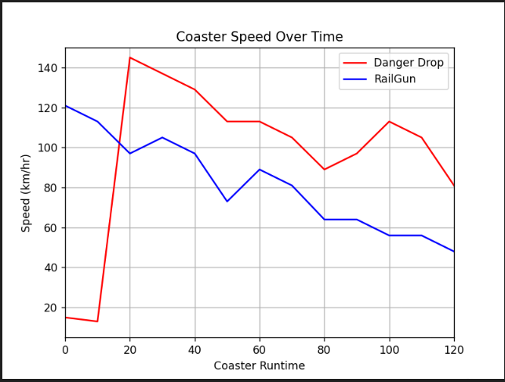

# Save figure

plt.savefig("../Images/CoasterSpeed.png")

plt.show()

**Day 1, Activity 7 🡪 Bar Chart**

import matplotlib.pyplot as plt

import numpy as np

# Create an array that contains the number of users each language has

users = [13000, 26000, 52000, 30000, 9000]

x_axis = np.arange(len(users))

# Tell matplotlib that we will be making a bar chart

# Users is our y axis and x_axis is, of course, our x axis

# We apply align="center" to ensure our bars line up with our tick marks

plt.bar(x_axis, users, color='r', alpha=0.5, align="center")

# Tell matplotlib where we would like to place each of our x axis headers

tick_locations = [value for value in x_axis]

plt.xticks(tick_locations, ["Java", "C++", "Python", "Ruby", "Clojure"])

# Sets the x limits of the current chart

plt.xlim(-0.75, len(x_axis)-0.25)

# Sets the y limits of the current chart

plt.ylim(0, max(users)+5000)

# Give our chart some labels and a tile

plt.title("Popularity of Programming Languages")

plt.xlabel("Programming Language")

plt.ylabel("Number of People Using Programming Languages")

plt.show()

**Day 1, Activity 8 🡪 Bar Chart**

import matplotlib.pyplot as plt

import numpy as np

cities = ["San Francisco", "Omaha", "New Orleans", "Cincinnati", "Pittsburgh"]

cars_in_cities = [214.7, 564.4, 416.5, 466.7, 350.6]

x_axis = np.arange(len(cars_in_cities))

# Create a bar chart based upon the above data

plt.bar(x_axis, cars_in_cities, color="b", align="center")

# Create the ticks for our bar chart's x axis

tick_locations = [value for value in x_axis]

plt.xticks(tick_locations, cities)

# Set the limits of the x axis

plt.xlim(-0.75, len(x_axis)-0.25)

# Set the limits of the y axis

plt.ylim(0, max(cars_in_cities)+10)

# Give the chart a title, x label, and y label

plt.title("Density of Commuting Cars in Cities")

plt.xlabel("Cities")

plt.ylabel("Commuting Cars Per 1,000 Population Age 16+")

plt.show()

# Save an image of the chart and print it to the screen

plt.savefig("../Images/CarDensity.png")

plt.show()

**Day 1, Activity 9 🡪 Pie Charts**

# Import our dependencies

import matplotlib.pyplot as plt

import numpy as np

# Labels for the sections of our pie chart

labels = ["Humans", "Smurfs", "Hobbits", "Ninjas"]

# The values of each section of the pie chart

sizes = [220, 95, 80, 100]

# The colours of each section of the pie chart

colours = ["red", "orange", "lightcoral", "lightskyblue"]

# Tells matplotlib to separate the "Humans" section from the others

explode = (0.1, 0, 0, 0)

# Creates the pie chart based upon the values above

# Automatically finds the percentages of each part of the pie chart

plt.pie(sizes, explode=explode, labels=labels, colors=colours,

        autopct="%1.1f%%", shadow=True, startangle=140)

plt.show()

# Tells matplotlib that we want a pie chart with equal axes

plt.axis("equal")

plt.show()

**Day 1, Activity 10 🡪 Pie Charts**

import matplotlib.pyplot as plt

import numpy as np

pies = ["Aussie Beef", "Apple", "Chicken", "Lemon Meringue", "Shepherds", "Steak and Kidney", "Curry", "Lamb and Rosemary", "Steak and Mushroom", "Spinach and Feta"]

pie_votes = [47,37,32,27,25,24,24,21,18,16]

colours = ["orange","green","lightblue","yellow","red","purple","pink","yellowgreen","lightskyblue","lightcoral"]

# Add explode levels for each value

explode = (0.1,0,0,0,0,0,0,0,0,0)

# Tell matplotlib to create a pie chart based upon the above data

plt.pie(pie_votes, explode=explode, labels=pies, colors=colours,

        autopct="%1.1f%%", shadow=True, startangle=140)

# Create axes which are equal so we have a perfect circle

plt.axis("equal")

# Save an image of our chart and print the final product to the screen

plt.savefig("../Images/PyPies.png")

plt.show()

**Day 1, Activity 11 🡪 Scatter Plot**

# Import Dependencies

import random

import matplotlib.pyplot as plt

import numpy as np

# The maximum x value for our chart will be 100

x_limit = 100

# List of values from 0 to 100 each value being 1 greater than the last

x_axis = np.arange(0, x_limit, 1)

# Create a random array of data that we will use for our y values

data = [random.random() for value in x_axis]

# Tells matplotlib that we want to make a scatter plot

# The size of each point on our plot is determined by their x value

plt.scatter(x_axis, data, marker="o", facecolors="red", edgecolors="black",

            s=x_axis, alpha=0.75)

# The y limits of our scatter plot is 0 to 1

plt.ylim(0, 1)

# The x limits of our scatter plot is 0 to 100

plt.xlim(0, x_limit)

plt.show()

**Day 1, Activity 12 🡪 Scatter Plot – Ice Cream Sales**

import matplotlib.pyplot as plt

import numpy as np

temp = [14.2, 16.4, 11.9, 15.2, 18.5, 22.1, 19.4, 25.1, 23.4, 18.1, 22.6, 17.2]

sales = [215, 325, 185, 332, 406, 522, 412, 614, 544, 421, 445, 408]

# Tell matplotlib to create a scatter plot based upon the above data

# Without scoop_price

# plt.scatter(temp, sales, marker="o", facecolors="red", edgecolors="black")

# BONUS: With scoop_price set to the scalar value

scoop_price = [89, 18, 10, 28, 79, 46, 29, 38, 89, 26, 45, 62]

plt.scatter(temp, sales, marker="o", facecolors="red", edgecolors="black", s=scoop_price)

# Set the upper and lower limits of our y axis

plt.ylim(180,620)

# Set the upper and lower limits of our x axis

plt.xlim(11,26)

# Create a title, x label, and y label for our chart

plt.title("Ice Cream Sales v Temperature")

plt.xlabel("Temperature (Celsius)")

plt.ylabel("Sales (Dollars)")

plt.show()

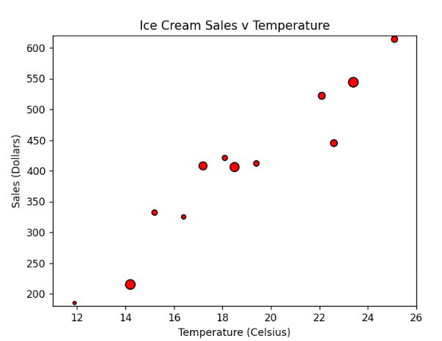

# Save an image of the chart and print to screen

# NOTE: If your plot shrinks after saving an image,

# update matplotlib to 2.2 or higher,

# or simply run the above cells again.

plt.savefig("../Images/IceCreamSales.png")

plt.show()

**Day 1, Activity 13 🡪 Avg Cities Rain (using Pandas)**

# Dependencies

import matplotlib.pyplot as plt

import numpy as np

import pandas as pd

# Load in csv

rain_df = pd.read_csv("../Resources/avg_rain_cities.csv")

rain_df.head()

# Set x axis and tick locations

x_axis = np.arange(len(rain_df))

tick_locations = [value+0.4 for value in x_axis]

# Create a list indicating where to write x labels and set figure size to adjust for space

plt.figure(figsize=(8,5))

plt.bar(x_axis, rain_df["ANNUAL (mm)"], color='r', alpha=0.5, align="edge")

plt.xticks(tick_locations, rain_df["LOCATION"], rotation="vertical")

# Set x and y limits

plt.xlim(-0.15, len(x_axis)-0.05)

plt.ylim(0, max(rain_df["ANNUAL (mm)"])+50)

# Set a Title and labels

plt.title("Average Rain in Major Cities")

plt.xlabel("City")

plt.ylabel("Average Amount of Rainfall in Millimetres")

plt.show()

# Save our graph and show the grap

plt.tight_layout()

plt.savefig("../Images/avg_cities_rain.png")

plt.show()

**Day 2, Activity 1 🡪 Plot Drills - Gym**

# Import Dependencies

import numpy as np

import matplotlib.pyplot as plt

# DATA SET 1

gyms = ["Crunch", "Planet Fitness", "NY Sports Club", "Rickie's Gym"]

members = [49, 92, 84, 53]

x_axis = np.arange(0, len(gyms))

tick_locations = []

for x in x_axis:

    tick_locations.append(x)

plt.title("NYC Gym Popularity")

plt.xlabel("Gym Name")

plt.ylabel("Number of Members")

plt.xlim(-0.75, len(gyms)-.25)

plt.ylim(0, max(members) + 5)

plt.bar(x_axis, members, facecolor="red", alpha=0.75, align="center")

plt.xticks(tick_locations, gyms)

plt.show()

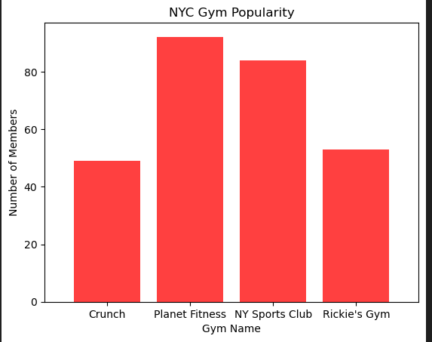

# DATA SET 2

x_lim = 2 * np.pi

x_axis = np.arange(0, x_lim, 0.1)

sin = np.sin(x_axis)

plt.title("Sin from 0 to 2$\pi$")

plt.xlabel("Real Numbers from 0 to 2$\pi$")

plt.ylabel("sin(x)")

plt.hlines(0, 0, x_lim, alpha=0.2)

plt.xlim(0, x_lim)

plt.ylim(-1.25, 1.25)

plt.plot(x_axis, sin, marker="o", color="red", linewidth=1)

plt.show()

# DATA SET 3

gyms = ["Crunch", "Planet Fitness", "NY Sports Club", "Rickie's Gym"]

members = [49, 92, 84, 53]

colours = ["yellowgreen", "red", "lightcoral", "lightskyblue"]

explode = (0, 0.05, 0, 0)

plt.title("NYC Gym Popularity")

plt.pie(members, explode=explode, labels=gyms, colors=colours,

        autopct="%1.1f%%", shadow=True, startangle=90)

plt.axis("equal")

plt.show()

# DATA SET 4

x_axis = np.arange(0, 10, 0.1)

times = []

for x in x_axis:

    times.append(x * x + np.random.randint(0, np.ceil(max(x_axis))))

plt.title("Running Time of FakeSort for Sample Input Sizes")

plt.xlabel("Length of Input Array")

plt.ylabel("Time to Sort (s)")

plt.scatter(x_axis, times, marker="o", color="red")

plt.show()

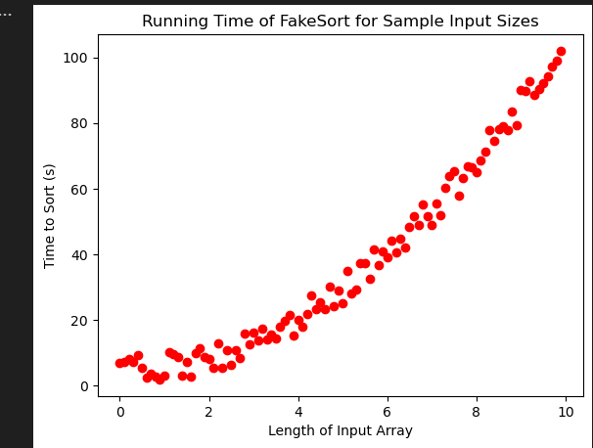

**Day 2, Activity 2 – Avg State Rain**

# Dependencies

import matplotlib.pyplot as plt

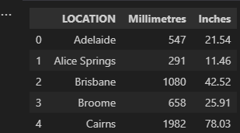import numpy as np

import pandas as pd

#Using MatpltLib to Chart a DataFrame

# Load in csv

rain_df = pd.read_csv("../Resources/avg_rain_cities.csv")

rain_df.head()

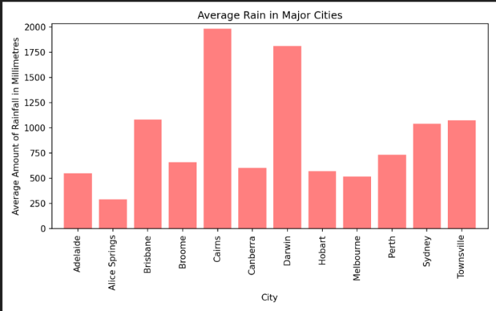# Set x axis and tick locations

x_axis = np.arange(len(rain_df))

tick_locations = [value for value in x_axis]

# Create a list indicating where to write x labels and set figure size to adjust for space

plt.figure(figsize=(8,5))

plt.bar(x_axis, rain_df["Millimetres"], color='r', alpha=0.5, align="center")

plt.xticks(tick_locations, rain_df["LOCATION"], rotation="vertical")

# Set x and y limits

plt.xlim(-0.75, len(x_axis)-0.25)

plt.ylim(0, max(rain_df["Millimetres"])+50)

… (0.0, 2032.0)

# Set a Title and labels

plt.title("Average Rain in Major Cities")

plt.xlabel("City")

plt.ylabel("Average Amount of Rainfall in Millimetres")

**…** Text(0, 0.5, 'Average Amount of Rainfall in Millimetres')

# Save our graph and show the grap

plt.tight_layout()

plt.savefig("../Images/avg_cities_rain.png")

plt.show()

… <Figure size 640X180 with 0 Axes>

**Using Pandas to Chart a DataFrame**

# Filter the DataFrame down only to those columns to chart

city_and_mm = rain_df[["LOCATION","Millimetres"]]

# Set the index to be "State" so they will be used as labels

city_and_mm = city_and_mm.set_index("LOCATION")

city_and_mm.head()

****# Use DataFrame.plot() in order to create a bar chart of the data

city_and_mm.plot(kind="bar", figsize=(6,5))

# Set a title for the chart

plt.title("Average Rain Per City")

plt.show()

plt.tight_layout()

# Pandas can also plot multiple columns if the DataFrame includes them

multi_plot = rain_df.plot(kind="bar", figsize=(8,5))

# PandasPlot.set_xticklabels() can be used to set the tick labels as well

multi_plot.set_xticklabels(rain_df["LOCATION"], rotation=45)

plt.show()

plt.tight_layout()

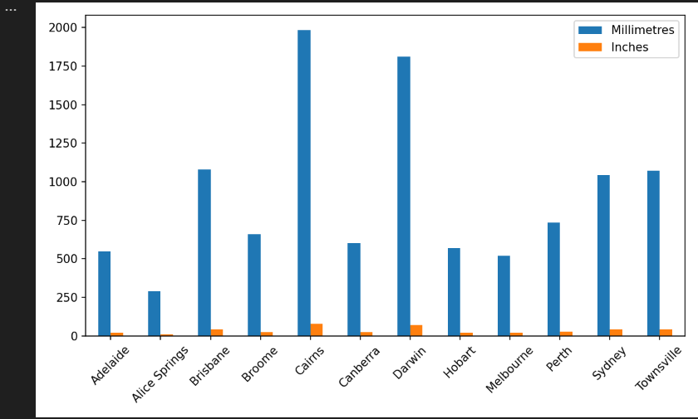

**Day 2, Activity 3**

# Dependencies

import matplotlib.pyplot as plt

import numpy as np

import pandas as pd

# Read CSV

settlement_data = pd.read_csv("Resources/union_settlements_1995.csv")

settlement_data.head()

# List columns

****settlement_data.columns

# Get total settlements by union

union_data = settlement_data["UNION"].value_counts()

# Configure plot, figsize, title, and axis labels

figure1 = union_data.plot(kind="bar", facecolor="red", figsize=(8,6),

                                title="Major Collective Bargaining Settlements (1995)")

figure1.set_xlabel("Union")

figure1.set_ylabel("Settlements")

# Configure x-tick rotation

xticklabels = union_data.index

figure1.set_xticklabels(xticklabels, rotation=45, rotation_mode="anchor", ha="right", wrap=True)

# Show plot

plt.show()

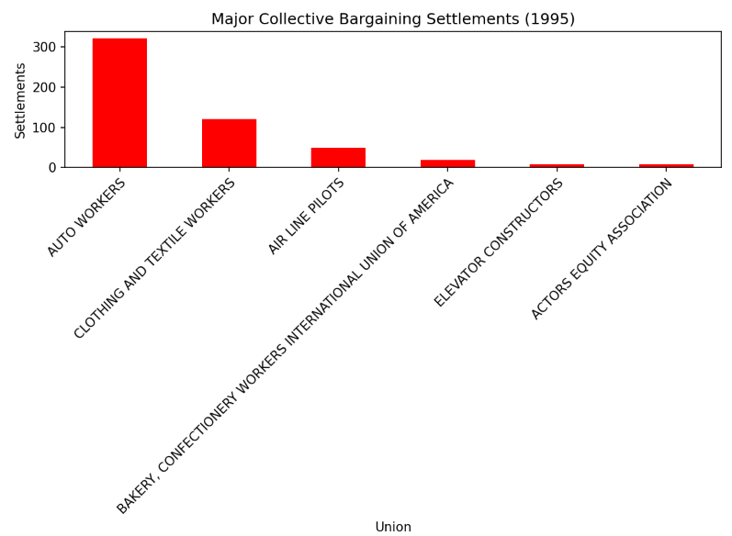

# Resize plot to display labels

plt.tight_layout()

**BONUS Question**

# Get total settlements by union

union_data = settlement_data["UNION"].value_counts()

# Filter data to national settlements

national_settlements = settlement_data.loc[settlement_data["LOCATION"]=="NATIONAL",:]

national_settlements

# Get national settlements by union

national_union_data = national_settlements["UNION"].value_counts()

# Create new dataframe for data to chart (has NaN)

compare_all_national_df = pd.DataFrame({"National Settlements": national_union_data,

                                       "All Settlements": union_data})

compare_all_national_df

# Fill NA

compare_all_national_df = compare_all_national_df.fillna(0)

compare_all_national_df

# Configure plot, figsize, title, and axis labels

figure1 = compare_all_national_df.plot(kind="bar", color=["red", "blue"], figsize=(8,6),

                                   title="Major Collective Bargaining Settlements (1995)")

figure1.set_xlabel("Union")

figure1.set_ylabel("Settlements")

# Configure x-tick rotation

xticklabels = compare_all_national_df.index

figure1.set_xticklabels(xticklabels, rotation=45, rotation_mode="anchor", ha="right", wrap=True)

# Show plot

plt.show()

**Activity 4 – Ins GroupPlots**

# Import Dependencies

import matplotlib.pyplot as plt

import pandas as pd

# Import our data into pandas from CSV

accident_string = '../Resources/accidents.csv'

accidents_df = pd.read_csv(accident_string, low_memory=False)

accidents_df

# Create a group based on the values in the 'FUNC_SYSNAME' column

# 'FUNC_SYSNAME' stores the type of road the accident occurred

accident_road_type = accidents_df.groupby('FUNC_SYSNAME')

# Count how many times each road type appears in our group

count_road_types = accident_road_type['FUNC_SYSNAME'].count()

count_road_types

# Create a bar chart based off of the group series from before

count_chart = count_road_types.plot(kind='bar', figsize=(6,8))

# Set the xlabel and ylabel using class methods

count_chart.set_xlabel("Road Type")

count_chart.set_ylabel("Number of Accidents")

plt.show()

plt.tight_layout()

**Day 2, Activity 5 – Student Library Usage – Groupby (Pie chart)**

# Import Dependencies

import matplotlib.pyplot as plt

import pandas as pd

import numpy as np

# Import our data into pandas from CSV

string_thing = '../Resources/library_usage.csv'

library_usage_df = pd.read_csv(string_thing, low_memory=False)

library_usage_df.head()

# Filter data so it only includes patrons who checked out at least one item

library_loans_df = pd.DataFrame(library_usage_df.loc[library_usage_df['Total Checkouts']>0,:])

# Split up our data into groups based upon 'Patron Type Definition'

patron_groups = library_loans_df.groupby('Patron Type Definition')

# Find out how many of each patron type borrowed library items

patron_borrows = patron_groups['Total Checkouts'].count()

# Chart our data, give it a title, and label the axes

patron_chart = patron_borrows.plot(kind="bar", title="Library Usage by Patron Type")

patron_chart.set_xlabel("Patron Type")

patron_chart.set_ylabel("Number of Patrons Borrowing Items")

plt.show()

plt.tight_layout()

# Split up our data into groups based upon 'Home Library Definition' and 'Patron Type Definition'

library_groups = library_usage_df.groupby(['Home Library Definition','Patron Type Definition'])

# Create a new variable that holds the sum of our groups

sum_it_up = library_groups[['Total Checkouts']].sum()

sum_it_up.head(20)

# Make a variable called branch and store a 'Home Library Definition' in it

branch = "Anza"

# Make a variable called min_checkouts that you can change depending on how busy the library branch you've chosen is

min_checkouts = 5000

# Collect the loans of the branch above

just_one_branch = sum_it_up.loc[branch]

# filter the data to patron types with greater than the value set for min_checkouts

just_one_branch = just_one_branch.loc[just_one_branch['Total Checkouts']>min_checkouts,:]

# Create a pie chart based upon the total checkouts (or loans) of that single branch

branch_pie = just_one_branch.plot(kind="pie", y='Total Checkouts', title=("Loans of " + branch +

                                                                          " Branch for Patron Types Over "

                                                                         + str(min_checkouts) + " Loaned Items"))

branch_pie.set_ylabel("Branch Checkouts")

plt.axis("equal")

plt.show()

**Day 2, Activity 6 – Student L Per 100km-ScatterPlot**

# Dependencies and Setup

import matplotlib.pyplot as plt

import pandas as pd

import numpy as np

# Import our data into pandas from CSV

car_data = pd.read_csv('../Resources/Lp100km.csv')

car_data.head()

# Remove the rows with missing values in horsepower

car_data = car_data.loc[car_data['horsepower'] != "?"]

car_data.head()

**index 2 got  
 removed**

# Set the 'car name' as our index

car_data = car_data.set_index('car name')

# Remove the 'origin' column

del car_data['origin']

car_data.head()

# Convert the "horsepower" column to numeric so the data can be used

car_data['horsepower'] = pd.to_numeric(car_data['horsepower'])

# Create a scatter plot which compares L/100km to horsepower

car_data.plot(kind="scatter", x="horsepower", y="L/100km", grid=True, figsize=(8,8),

              title="L/100km Vs. Horsepower")

plt.show()

**Day 2, Activity 7 – Instructor Pandas Multi Line**

# Dependencies

import matplotlib.pyplot as plt

import numpy as np

import pandas as pd

# Read CSV

unemployed_data_one = pd.read_csv("../Resources/unemployment_2010-2015.csv")

unemployed_data_two = pd.read_csv("../Resources/unemployment_2016-2020.csv")

# Merge our two data frames together

combined_unemployed_data = pd.merge(unemployed_data_one, unemployed_data_two, on="Country Name")

****combined_unemployed_data.head()

# Delete the duplicate 'Country Code' column and rename the first one back to 'Country Code'

del combined_unemployed_data['Country Code_y']

combined_unemployed_data = combined_unemployed_data.rename(columns={"Country Code_x":"Country Code"})

****combined_unemployed_data.head()

# Set the 'Country Code' to be our index for easy referencing of rows

combined_unemployed_data = combined_unemployed_data.set_index("Country Code")

# Collect the mean unemployment rates for the world

average_unemployment = combined_unemployed_data.select_dtypes(include=np.number).mean()

# Collect the years where data was collected

years = average_unemployment.keys()

years



# Plot the world average as a line chart

world_avg, = plt.plot(years, average_unemployment, color="blue", label="World Average" )

# Plot the unemployment values for a single country

country_one, = plt.plot(years, combined_unemployed_data.loc['AUS',["2010","2011","2012","2013","2014","2015",

                                                                  "2016","2017","2018","2019","2020"]],

                        color="green",label=combined_unemployed_data.loc['AUS',"Country Name"])

# Create a legend for our chart

plt.legend(handles=[world_avg, country_one], loc="best")

# Show the chart

plt.show()

average_unemployment.plot(label="World Average")

combined_unemployed_data.loc['AUS', "2010":"2020"].plot(label="Australia")

plt.legend()

plt.show()

**Day 2, Activity 8 – Student Travel Part 1**

**# Travelling Companions**

In this activity you will be taking three separate csvs that were gathered by Tourism Malaysia, merging them together, and then creating charts to visualise a country's change of travelling companions to Malaysia over the course of three years.

**### Part 1 - Merging Companions**

* You will likely need to perform two different merges over the course of this activity, changing the names of your columns as you go along.

import matplotlib.pyplot as plt

import pandas as pd

import numpy as np

# Take in all of our traveller data and read it into pandas

travel_2016 = "../Resources/2016_travellers.csv"

travel_2017 = "../Resources/2017_travellers.csv"

travel_2018 = "../Resources/2018_travellers.csv"

travel_2016_df = pd.read_csv(travel_2016)

travel_2017_df = pd.read_csv(travel_2017)

travel_2018_df = pd.read_csv(travel_2018)

# Merge the first two datasets on "COUNTRY OF NATIONALITY" so that no data is lost (should be 44 rows)

combined_travel_df = pd.merge(travel_2016_df, travel_2017_df,

                                 how='outer', on='COUNTRY OF NATIONALITY')

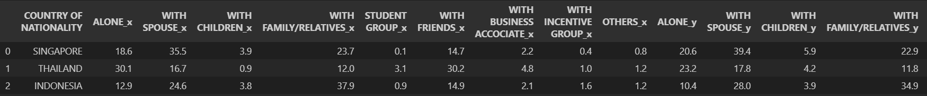combined_travel_df.head()

# Rename our _x columns to "2016 Alone", "2016 With Spouse", "2016 With Children", "2016 With Family/Relatives",

# "2016 Student Group", "2016 With Friends", "2016 With Business Associate", "2016 With Incentive Group",

# and "2016 Others"

combined_travel_df = combined_travel_df.rename(columns={"ALONE_x":"2016 Alone",

                                                        "WITH SPOUSE_x":"2016 With Spouse",

                                                        "WITH CHILDREN_x":"2016 With Children",

                                                        "WITH FAMILY/RELATIVES_x":"2016 With Family/Relatives",

                                                        "STUDENT GROUP_x":"2016 Student Group",

                                                        "WITH FRIENDS_x":"2016 With Friends",

                                                        "WITH BUSINESS ACCOCIATE_x":"2016 With Business Associate",

                                                        "WITH INCENTIVE GROUP_x":"2016 With Incentive Group",

                                                        "OTHERS_x":"2016 Others"})

# Rename our _y columns to "2016 Alone", "2016 With Spouse", "2016 With Children", "2016 With Family/Relatives",

# "2016 Student Group", "2016 With Friends", "2016 With Business Associate", "2016 With Incentive Group",

# and "2016 Others"

combined_travel_df = combined_travel_df.rename(columns={"ALONE_y":"2017 Alone",

                                                        "WITH SPOUSE_y":"2017 With Spouse",

                                                        "WITH CHILDREN_y":"2017 With Children",

                                                        "WITH FAMILY/RELATIVES_y":"2017 With Family/Relatives",

                                                        "STUDENT GROUP_y":"2017 Student Group",

                                                        "WITH FRIENDS_y":"2017 With Friends",

                                                        "WITH BUSINESS ACCOCIATE_y":"2017 With Business Associate",

                                                        "WITH INCENTIVE GROUP_y":"2017 With Incentive Group",

                                                        "OTHERS_y":"2017 Others"})

combined_travel_df.head()

# Merge our newly combined dataframe with the 2018 dataframe

combined_travel_df = pd.merge(combined_travel_df, travel_2018_df, how="outer", on="COUNTRY OF NATIONALITY")

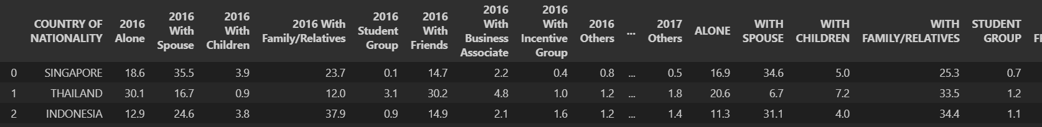combined_travel_df

# Rename "ALONE", "WITH SPOUSE", "WITH CHILDREN", "WITH FAMILY/RELATIVES", "STUDENT GROUP", "WITH FRIENDS",

# "WITH BUSINESS ACCOCIATE","WITH INCENTIVE GROUP", "OTHERS" to

# "2018 Alone", "2018 With Spouse", "2018 With Children", "2018 With Family/Relatives", "2018 Student Group",

# "2018 With Friends", "2018 With Business Associate", "2018 With Incentive Group", and "2018 Others"

combined_travel_df = combined_travel_df.rename(columns={"ALONE":"2018 Alone",

                                                        "WITH SPOUSE":"2018 With Spouse",

                                                        "WITH CHILDREN":"2018 With Children",

                                                        "WITH FAMILY/RELATIVES":"2018 With Family/Relatives",

                                                        "STUDENT GROUP":"2018 Student Group",

                                                        "WITH FRIENDS":"2018 With Friends",

                                                        "WITH BUSINESS ACCOCIATE":"2018 With Business Associate",

                                                        "WITH INCENTIVE GROUP":"2018 With Incentive Group",

                                                        "OTHERS":"2018 Others"})

combined_travel_df.head()

**### Part 2**

# Check the mean of the columns

combined_travel_df.select_dtypes(include=np.number).mean()

# Reduce columns where mean of travelling companions is > 1 across all years

travel_reduced = pd.DataFrame(combined_travel_df[["COUNTRY OF NATIONALITY",

                                                  "2016 Alone","2016 With Spouse","2016 With Children",

                                                  "2016 With Family/Relatives","2016 With Friends",

                                                  "2016 With Business Associate","2017 Alone",

                                                  "2017 With Spouse","2017 With Children",

                                                  "2017 With Family/Relatives","2017 With Friends",

                                                  "2017 With Business Associate","2018 Alone",

                                                  "2018 With Spouse","2018 With Children",

                                                  "2018 With Family/Relatives","2018 With Friends",

                                                  "2018 With Business Associate"]])

# Set index to "Country of Nationality"

travel_reduced = travel_reduced.set_index("COUNTRY OF NATIONALITY")

travel_reduced

**Part 3**

# Create a variable for each country to chart

country1 = "AUSTRALIA"

country2 = "THAILAND"

country3 = "PHILIPPINES"

# Set type of travelling companion

columns_to_compare = "With Spouse"

# Create a Series for each chosen country that looks for the chosen travel companion from 2016 to 2018

country1_traveller_over_time = travel_reduced.loc[country1,

                                                [f"2016 {columns_to_compare}",

                                                 f"2017 {columns_to_compare}",

                                                 f"2018 {columns_to_compare}"]]

country2_traveller_over_time = travel_reduced.loc[country2,

                                                [f"2016 {columns_to_compare}",

                                                 f"2017 {columns_to_compare}",

                                                 f"2018 {columns_to_compare}"]]

country3_traveller_over_time = travel_reduced.loc[country3,

                                                [f"2016 {columns_to_compare}",

                                                 f"2017 {columns_to_compare}",

                                                 f"2018 {columns_to_compare}"]]

# Create a list of the years that we will use as our x axis

years = [2016,2017,2018]

# Plot our line that will be used to track the first country's travelling companion percentage over the years

plt.plot(years, country1_traveller_over_time, color="green", label=country1)

# Plot our line that will be used to track the second country's travelling companion percentage over the years

plt.plot(years, country2_traveller_over_time, color="blue", label=country2)

# Plot our line that will be used to track the third country's travelling companion percentage over the years

plt.plot(years, country3_traveller_over_time, color="orange", label=country3)

# Place a legend on the chart in what matplotlib believes to be the "best" location

plt.legend(loc="best")

plt.title("Travelling " + columns_to_compare + " Country Comparison")

plt.xlabel("Years")

plt.xticks(np.arange(min(years), max(years)+1, 1.0))

plt.ylabel("% Travellers")

# Print our chart to the screen

plt.show()

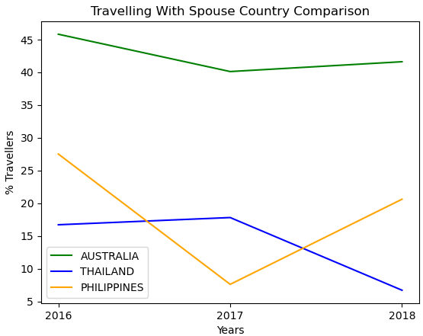

**### Part 3 - Charting Travelling Companions --bonus**

* Create 3 variables with inputs that asks the user what country they would like to chart.

* Ask the user what type of travelling companion they would like to compare for their chosen countries.

* Store each country's percentage of travellers for the chosen travelling companion over time in 3 variables (one for each country)

* Create a line chart that will plot the comparison of each country's percentage of travellers with the chosen traveling companion from 2016 to 2018

# Collect the user's input to search through our data frame

country1 = input("What country would you like to chart 1st? ")

country2 = input("What country would you like to chart 2nd? ")

country3 = input("What country would you like to chart 3rd? ")

Manual entry for input data! – Belgium / France / Australia

# Ask type of travelling companion

select_options = "1 - Alone\n2 - With Spouse\n3 - With Children\n4 - With Family/Relatives\n5 - With Friends\n6 - With Business Associate"

print("What type of travelling companion would you like to chart? ")

print(select_options)

traveller_type = int(input("Choose a number:  "))

# Boolean to check if number was correctly chosen

selected = False

# Loop through options to set column name according to chosen number

while selected == False:

    if traveller_type == 1:

        columns_to_compare = "Alone"

        selected = True

    elif traveller_type == 2:

        columns_to_compare = "With Spouse"

        selected = True

    elif traveller_type == 3:

        columns_to_compare = "With Children"

        selected = True

    elif traveller_type == 4:

        columns_to_compare = "With Family/Relatives"

        selected = True

    elif traveller_type == 5:

        columns_to_compare = "With Friends"

        selected = True

    elif traveller_type == 6:

        columns_to_compare = "With Business Associate"

        selected = True

    else:

        # Incorrect input, try again

        print("Please make your selection again.")

        print(select_options)

        traveller_type = int(input("Choose a number:  "))

print("You selected option " + str(traveller_type) + " - " + columns_to_compare)

Manual entry for input data! 1,2,3,4,5,6

# Create a Series for each chosen country that looks for the chosen travel companion from 2016 to 2018

country1_traveller_over_time = travel_reduced.loc[country1.upper(),

                                                [f"2016 {columns_to_compare}",f"2017 {columns_to_compare}", f"2018 {columns_to_compare}"]]

country2_traveller_over_time = travel_reduced.loc[country2.upper(),

                                                [f"2016 {columns_to_compare}",f"2017 {columns_to_compare}", f"2018 {columns_to_compare}"]]

country3_traveller_over_time = travel_reduced.loc[country3.upper(),

                                                [f"2016 {columns_to_compare}",f"2017 {columns_to_compare}", f"2018 {columns_to_compare}"]]

print information for each country

# Create a list of the years that we will use as our x axis

years = [2016,2017,2018]

# Plot our line that will be used to track the first country's travelling companion percentage over the years

plt.plot(years, country1_traveller_over_time, color="green", label=country1)

# Plot our line that will be used to track the second country's travelling companion percentage over the years

plt.plot(years, country2_traveller_over_time, color="blue", label=country2)

# Plot our line that will be used to track the third country's travelling companion percentage over the years

plt.plot(years, country3_traveller_over_time, color="orange", label=country3)

# Place a legend on the chart in what matplotlib believes to be the "best" location

plt.legend(loc="best")

plt.title("Travelling " + columns_to_compare + " Country Comparison")

plt.xlabel("Years")

plt.xticks(np.arange(min(years), max(years)+1, 1.0))

plt.ylabel("% Travellers")

# Print our chart to the screen

plt.show()

**Day 3 , Activity 1 🡪 Samples Solution**

# Dependencies

import pandas as pd

import matplotlib.pyplot as plt

import scipy.stats as st

import numpy as np

# Read in the LAX temperature data

temperature_df = pd.read_csv('../Resources/lax_temperature.csv')

temperatures = temperature_df['HourlyDryBulbTemperature (C)']

# Demonstrate calculating measures of central tendency

mean_numpy = np.mean(temperatures)

print(f"The mean temperature at the LAX airport is {mean_numpy}")

median_numpy = np.median(temperatures)

print(f"The median temperature at the LAX airport is {median_numpy}")

mode_scipy = st.mode(temperatures, keepdims=False)

print(f"The mode temperature at the LAX airport is {mode_scipy[0]}")

The mean temperature at the LAX airport is 14.252394446018743

The median temperature at the LAX airport is 13.9

The mode temperature at the LAX airport is 13.9

# Characterize the data set using matplotlib and stats.normaltest

plt.hist(temperatures)

plt.xlabel('Temperature (°C)')

plt.ylabel('Counts')

plt.show()

print(st.normaltest(temperatures.sample(50)))

# Run the normality test on the whole temperatures DataFrame.

print(st.normaltest(temperatures.sample(3529)))

NormaltestResult(statistic=203.70256859680273, pvalue=5.841834570719453e-45)

# Demonstrate calculating the variance and standard deviation using the different modules (“ddof” mean ‘Delta degree of freedom’ used in stastical calcuiations, particularly used in Numpy and Panda

var_numpy = np.var(temperatures,ddof = 0)

print(f"The population variance using the NumPy module is {var_numpy}")

sd_numpy = np.std(temperatures,ddof = 0)

print(f"The population standard deviation using the NumPy module is {sd_numpy}")

The population variance using the NumPy module is 9.985231585982183

The population standard deviation using the NumPy module is 3.159941706105064

# Calculate the 68-95-99.7 rule using the standard deviation

print(f"Roughly 68% of the data is between {round(mean_numpy-sd_numpy,3)} and {round(mean_numpy+sd_numpy,3)}")

print(f"Roughly 95% of the data is between {round(mean_numpy-2*sd_numpy,3)} and {round(mean_numpy+2*sd_numpy,3)}")

print(f"Roughly 99.7% of the data is between {round(mean_numpy-3*sd_numpy,3)} and {round(mean_numpy+3*sd_numpy,3)}")

Roughly 68% of the data is between 11.092 and 17.412

Roughly 95% of the data is between 7.933 and 20.572

Roughly 99.7% of the data is between 4.773 and 23.732

# Demonstrate calculating the z-scores using SciPy

z_scipy = st.zscore(temperatures)

print(f"The z-scores using the SciPy module are {z_scipy}")

The z-scores using the SciPy module are 0 -0.997612

1 -1.155842

2 -0.997612

3 -1.535596

4 -2.579919

...

3524 0.426465

3525 0.236588

3526 0.046711

3527 0.046711

3528 0.046711

Name: HourlyDryBulbTemperature (C), Length: 3529, dtype: float64

**Day 3 , Activity 2 🡪 Quartile and Outliners (Box Plot)**

# Dependencies

import pandas as pd

import numpy as np

import matplotlib.pyplot as plt

# Example outlier plot of reaction times

times = [96,98,100,105,85,88,95,100,101,102,97,98,5]

fig1, ax1 = plt.subplots()

ax1.set_title('Reaction Times at Tennis Batting Cage')

ax1.set_ylabel('Reaction Time (ms)')

ax1.boxplot(times)

plt.show()

# We need to sort the data to determine which could be outliers

times.sort()

print(times)

[5, 85, 88, 95, 96, 97, 98, 98, 100, 100, 101, 102, 105]

# The second example again looks at the LAX temperature data set and computes quantiles

temperature_df = pd.read_csv('../Resources/lax_temperature.csv')

temperatures = temperature_df['HourlyDryBulbTemperature (C)']

fig1, ax1 = plt.subplots()

ax1.set_title('Temperatures at LAX')

ax1.set_ylabel('Temperature (°C)')

ax1.boxplot(temperatures)

plt.show()

# If the data is in a dataframe, we use pandas to give quartile calculations

quartiles = temperatures.quantile([.25,.5,.75])

lowerq = quartiles[0.25]

upperq = quartiles[0.75]

iqr = upperq-lowerq

print(f"The lower quartile of temperatures is: {lowerq}")

print(f"The upper quartile of temperatures is: {upperq}")

print(f"The interquartile range of temperatures is: {iqr}")

print(f"The the median of temperatures is: {quartiles[0.5]} ")

lower_bound = lowerq - (1.5*iqr)

upper_bound = upperq + (1.5*iqr)

print(f"Values below {lower_bound} could be outliers.")

print(f"Values above {upper_bound} could be outliers.")

The lower quartile of temperatures is: 12.2

The upper quartile of temperatures is: 15.6

The interquartile range of temperatures is: 3.4000000000000004

The the median of temperatures is: 13.9

Values below 7.099999999999999 could be outliers.

Values above 20.7 could be outliers.

**Day 3 , Activity 3 🡪 Summary Stats (Student to do)**

# Dependencies

import pandas as pd

import matplotlib.pyplot as plt

import scipy.stats as st

# Read in the california housing data set

california_data = pd.read_csv('../Resources/California_Housing.csv')

california_data.head()

|  | **MedInc** | **HouseAge** | **AveRooms** | **AveBedrms** | **Population** | **AveOccup** | **Latitude** | **Longitude** |
| --- | --- | --- | --- | --- | --- | --- | --- | --- |
| **0** | 5.2742 | 17.0 | 8.908654 | 1.884615 | 351.0 | 1.687500 | 32.98 | -117.27 |
| **1** | 1.8438 | 52.0 | 3.069847 | 1.044293 | 2382.0 | 4.057922 | 34.07 | -118.26 |
| **2** | 7.0691 | 13.0 | 6.689697 | 1.009697 | 2444.0 | 2.962424 | 37.57 | -121.87 |
| **3** | 5.4719 | 38.0 | 5.890080 | 0.957105 | 1228.0 | 3.292225 | 37.52 | -122.28 |
| **4** | 4.0156 | 35.0 | 6.195312 | 1.171875 | 669.0 | 5.226562 | 33.93 | -117.41 |

# Get the information on the DataFrame

california_data.info()

RangeIndex: 3000 entries, 0 to 2999

Data columns (total 8 columns):

# Column Non-Null Count Dtype

--- ------ -------------- -----

0 MedInc 3000 non-null float64

1 HouseAge 3000 non-null float64

2 AveRooms 3000 non-null float64

3 AveBedrms 3000 non-null float64

4 Population 3000 non-null float64

5 AveOccup 3000 non-null float64

6 Latitude 3000 non-null float64

7 Longitude 3000 non-null float64

dtypes: float64(8)

memory usage: 187.6 KB

# Determine which measure of central tendency is most appropriate to describe the Population

plt.hist(california_data['Population'])

plt.xlabel('Population')

plt.ylabel('Counts')

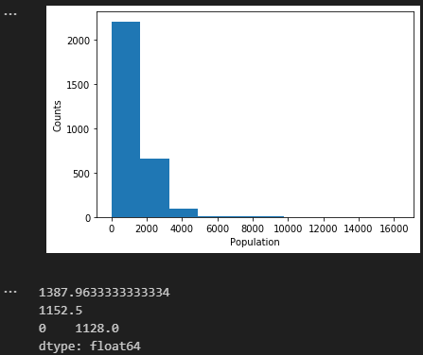plt.show()

print(california_data['Population'].mean())

print(california_data['Population'].median())

print(california_data['Population'].mode())

# Determine if the house age in California is normally distributed using a small and large sample size.

plt.hist(california_data['HouseAge'])

plt.xlabel('House Age (years)')

plt.ylabel('Counts')

plt.show()

print(st.normaltest(california_data["HouseAge"].sample(100)))

print(st.normaltest(california_data["HouseAge"].sample(2000)))

# Determine if there are any potential outliers in the average occupancy in California

quartiles = california_data['AveOccup'].quantile([.25,.5,.75])

lowerq = quartiles[0.25]

upperq = quartiles[0.75]

iqr = upperq-lowerq

print(f"The lower quartile of occupancy is: {lowerq}")

print(f"The upper quartile of occupancy is: {upperq}")

print(f"The interquartile range of occupancy is: {iqr}")

print(f"The the median of occupancy is: {quartiles[0.5]} ")

lower_bound = lowerq - (1.5*iqr)

upper_bound = upperq + (1.5*iqr)

print(f"Values below {lower_bound} could be outliers.")

print(f"Values above {upper_bound} could be outliers.")

outlier_occupancy = california_data.loc[(california_data['AveOccup'] < lower_bound) | (california_data['AveOccup'] > upper_bound)]

outlier_occupancy

# With the potential outliers, what is the lowest and highest median income (in $1000s) observed?

print(f"The minimum median income of the potential outliers is {outlier_occupancy['MedInc'].min()}")

print(f"The maximum median income of the potential outliers is {outlier_occupancy['MedInc'].max()}")



# Bonus - plot the latitude and longitude of the California housing data using Matplotlib, color the data points using the median income of the block.

plt.scatter(california_data['Longitude'],california_data['Latitude'],c=california_data['MedInc'])

clb = plt.colorbar()

plt.xlabel("Longitude")

plt.ylabel("Latitude")

clb.set_label("Median Income")

plt.show()

**Day 3, Activity 4 – Standard_error_solution**

# Dependencies

import pandas as pd

import random

import matplotlib.pyplot as plt

import numpy as np

from scipy.stats import sem

# Set the seed so our data is reproducible

random.seed(42)

# Sample versus population example fuel economy

fuel_economy = pd.read_csv('../Resources/2019_fuel_economy.csv')

# First overview the data set - how many factors, etc.

print(fuel_economy.head())

Type Combined_LP100KM Make_Model

0 Two Seaters 11.2007 Acura_NSX

1 Two Seaters 8.4184 ALFA ROMEO_4C

2 Two Seaters 11.2299 Aston Martin Lagonda Ltd_Vantage V8

3 Two Seaters 9.0484 Audi_TT Roadster quattro

4 Two Seaters 8.5130 BMW_Z4 sDrive30i

# Calculate the summary statistics and plot the histogram of the entire population data

print(f"The mean L/100km of all vehicles is: {round(fuel_economy['Combined_LP100KM'].mean(),2)}")

print(f"The standard deviation of all vehicle's L/100km is: {round(fuel_economy['Combined_LP100KM'].std(),2)}")

plt.hist(fuel_economy['Combined_LP100KM'])

plt.xlabel("Fuel Economy (L/100km)")

plt.ylabel("Number of Vehicles")

plt.show()

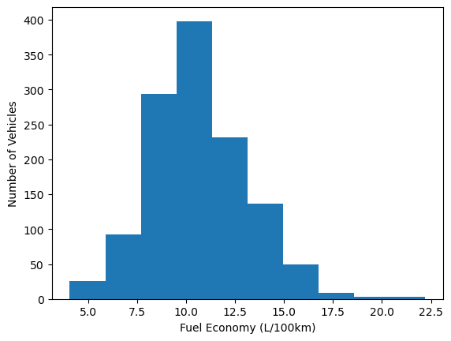The mean L/100km of all vehicles is: 10.67

The standard deviation of all vehicle's L/100km is: 2.47

# Calculate the summary statistics and plot the histogram of the sample data using iloc

subset = fuel_economy.iloc[range(766,856)]

print(f"The mean L/100km of all vehicles is: {round(subset['Combined_LP100KM'].mean(),2)}")

print(f"The standard deviation of all vehicle's L/100km is: {round(subset['Combined_LP100KM'].std(),2)}")

plt.hist(subset['Combined_LP100KM'])

plt.xlabel("Fuel Economy (L/100km)")

plt.ylabel("Number of Vehicles")

plt.show()

The mean L/100km of all vehicles is: 12.95

The standard deviation of all vehicle's L/100km is: 1.74

# Calculate the summary statistics and plot the histogram of the sample data using random sampling

subset = fuel_economy.sample(90)

print(f"The mean L/100km of all vehicles is: {round(subset['Combined_LP100KM'].mean(),2)}")

print(f"The standard deviation of all vehicle's L/100km is: {round(subset['Combined_LP100KM'].std(),2)}")

plt.hist(subset['Combined_LP100KM'])

plt.xlabel("Fuel Economy (L/100km)")

plt.ylabel("Number of Vehicles")

plt.show()

The mean L/100km of all vehicles is: 11.01

The standard deviation of all vehicle's L/100km is: 2.83

# Generate a new 30 vehicle sample and calculate the SEM of the sample

sample = fuel_economy.sample(30)

print(f"The SEM value for the sample fuel economy data is {sem(sample['Combined_LP100KM'])}")

The SEM value for the sample fuel economy data is 0.49228586996640716

# Create a sample set of 10, each with 30 vehicles

vehicle_sample_set = [fuel_economy.sample(30) for x in range(0,10)]

# Generate the plot data for each sample (‘sem’ = Std Error of Mean)

means = [sample['Combined_LP100KM'].mean() for sample in vehicle_sample_set]

standard_errors = [sem(sample['Combined_LP100KM']) for sample in vehicle_sample_set]

x_axis = np.arange(0, len(vehicle_sample_set), 1) + 1

# Setting up the plot

fig, ax = plt.subplots()

ax.errorbar(x_axis, means, standard_errors, fmt="o")

ax.set_xlim(0, len(vehicle_sample_set) + 1)

ax.set_ylim(9,13)

ax.set_xlabel("Sample Number")

ax.set_ylabel("Mean L/100km")

plt.show()

**Day 3, Activity 5 – Student to do – California Housing**

# Import dependencies

from matplotlib import pyplot as plt

import numpy as np

import pandas as pd

from sklearn.datasets import fetch_california_housing

from scipy.stats import sem

# Import the California housing data set and get description

california_dataset = fetch_california_housing()

print(california_dataset.DESCR)

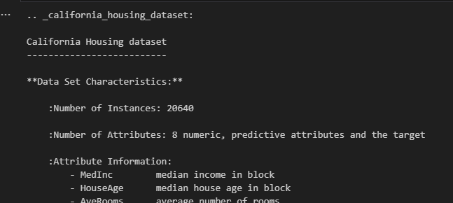

# Read California housing data into a Pandas dataframe

housing_data = pd.DataFrame(data=california_dataset.data,columns=california_dataset.feature_names)

housing_data['MEDV'] = california_dataset.target

housing_data.head()

# Create a bunch of samples, each with sample size of 20

nsamples = 25

div = 20

samples = [housing_data.sample(div) for x in range(0,nsamples)]

# Calculate means

means = [s['MEDV'].mean() for s in samples]

# Calculate standard error on means

sems = [sem(s['MEDV']) for s in samples]

# Plot sample means with error bars

fig, ax = plt.subplots()

ax.errorbar(np.arange(0, len(samples), 1)+1,means, yerr=sems, fmt="o", color="b",

            alpha=0.5, label="Mean of House Prices")

ax.set_xlim(0, len(means)+1)

ax.set_xlabel("Sample Number")

ax.set_ylabel("Mean of Median House Prices ($100,000)")

plt.legend(loc="best", fontsize="small", fancybox=True)

plt.show()

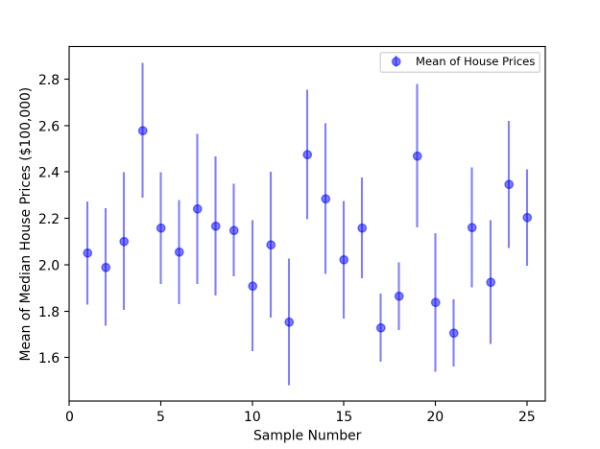

**Day 3, Activity 6 – Correlation Conundrum Solution**

# Dependencies

import pandas as pd

import matplotlib.pyplot as plt

import scipy.stats as st

# Import the WDI dataset, drop missing data

wdi_data = pd.read_csv('../Resources/WDI_2018.csv')

wdi_data = wdi_data.dropna()

wdi_data.head()

# For the first example, determine which pairs of factors are correlated.

plt.scatter(wdi_data.iloc[:,1],wdi_data.iloc[:,8])

plt.xlabel('Income Per Capita')

plt.ylabel('Average Alcohol Consumed Per Person Per Year (L)')

plt.show()

plt.scatter(wdi_data.iloc[:,3],wdi_data.iloc[:,10])

plt.xlabel('Population Median Age')

plt.ylabel('Cell Phones Per 100 People')

plt.show()

plt.scatter(wdi_data.iloc[:,9],wdi_data.iloc[:,7])

plt.xlabel('% Population with Access to Clean Water')

plt.ylabel('Male Life Expectancy')

plt.show()

plt.scatter(wdi_data.iloc[:,1],wdi_data.iloc[:,12])

plt.xlabel('Income Per Capita')

plt.ylabel('% Measles Immunisation')

plt.show()

# Compare the calcualted Pearson's r to the plots

plt.scatter(income,alcohol)

plt.xlabel('Income Per Capita')

plt.ylabel('Average Alcohol Consumed Per Person Per Year (L)')

print(f"The correlation between both factors is {round(correlation[0],2)}")

plt.show()

age = wdi_data.iloc[:,3]

cell_phones = wdi_data.iloc[:,10]

correlation = st.pearsonr(age,cell_phones)

plt.scatter(age,cell_phones)

plt.xlabel('Population Median Age')

plt.ylabel('Cell Phones Per 100 People')

print(f"The correlation between both factors is {round(correlation[0],2)}")

plt.show()

…The correlation between both factors is 0.53

water = wdi_data.iloc[:,9]

life = wdi_data.iloc[:,7]

correlation = st.pearsonr(water,life)

plt.scatter(water,life)

plt.xlabel('% Population with Access to Clean Water')

plt.ylabel('Male Life Expectancy')

print(f"The correlation between both factors is {round(correlation[0],2)}")

plt.show()

…The correlation between both factors is 0.83

income = wdi_data.iloc[:,1]

measles = wdi_data.iloc[:,12]

correlation = st.pearsonr(income,measles)

plt.scatter(income,measles)

plt.xlabel('Income Per Capita')

plt.ylabel('% Measles Immunisation')

print(f"The correlation between both factors is {round(correlation[0],2)}")

plt.show()

…The correlation between both factors is 0.34

**Day 3, activity 7 - Wine**

# Dependencies

import pandas as pd

import sklearn.datasets as dta

import scipy.stats as st

import matplotlib.pyplot as plt

# Read in the wine recognition data set from sklearn and load into Pandas

data = dta.load_wine()

wine_data = pd.DataFrame(data.data,columns=data.feature_names)

print(data.DESCR)

# Plot flavanoids versus malic_acid on a scatterplot

flavanoids = wine_data['flavanoids']

malic_acid = wine_data['malic_acid']

plt.scatter(malic_acid,flavanoids)

plt.xlabel("Amount of Malic Acid")

plt.ylabel("Amount of Flavanoids")

plt.show()

…Graph

# Calculate the correlation coefficient between malic_acid and flavanoids

print(f"The correlation coefficient between malic acid and flavanoids is {round(st.pearsonr(malic_acid,flavanoids)[0],2)}")

…The correlation coefficient between malic acid and flavanoids is -0.41

# Plot colour_intensity versus alcohol on a scatterplot

colour_intensity = wine_data['color_intensity']

alcohol = wine_data['alcohol']

plt.scatter(alcohol,colour_intensity)

plt.xlabel("Amount of Alcohol")

plt.ylabel("Intensity of Colour")

plt.show()

# Calculate the correlation coefficient between alcohol and colour_intensity

print(f"The correlation coefficient between alcohol and color intensity is {round(st.pearsonr(alcohol,colour_intensity)[0],2)}")

…The correlation coefficient between alcohol and color intensity is 0.55

# BONUS: Generate the correlation matrix and find the strongest positive and negative correlations

wine_corr = wine_data.corr()

wine_corr.unstack().sort_values()

**Day 3, activity 8 - California Housing (Regression)**

# Import dependencies

from matplotlib import pyplot as plt

from scipy.stats import linregress

import numpy as np

from sklearn import datasets

import pandas as pd

**Compare different factors in the California housing dataset**

# Read in the California housing dataset

california_dataset = datasets.fetch_california_housing()

housing_data = pd.DataFrame(data=california_dataset.data,columns=california_dataset.feature_names)

housing_data['MEDV'] = california_dataset.target

# Reduce the dataset to remove AveRooms outliers

housing_data_reduced = pd.DataFrame(housing_data.loc[housing_data['AveRooms']<10,:])

# Reduce the dataset to the San Diego Area (based on approx latitude & longitude area)

san_diego_housing = pd.DataFrame(housing_data_reduced.loc[((housing_data_reduced['Latitude']>32.664282) &

                                                          (housing_data_reduced['Latitude']<32.980514) &

                                                          (housing_data_reduced['Longitude']>-117.300418) &

                                                          (housing_data_reduced['Longitude']<-117.01950)),:])

# Plot out rooms versus median house price

x_values = san_diego_housing['AveRooms']

y_values = san_diego_housing['MEDV']

plt.scatter(x_values,y_values)

plt.xlabel('Rooms in House')

plt.ylabel('Median House Prices ($100,000)')

plt.show()

# Add the linear regression equation and line to plot

x_values = san_diego_housing['AveRooms']

y_values = san_diego_housing['MEDV']

(slope, intercept, rvalue, pvalue, stderr) = linregress(x_values, y_values)

regress_values = x_values * slope + intercept

line_eq = "y = " + str(round(slope,2)) + "x + " + str(round(intercept,2))

plt.scatter(x_values,y_values)

plt.plot(x_values,regress_values,"r-")

plt.annotate(line_eq,(5.8,0.8),fontsize=15,color="red")

plt.xlabel('Rooms in House')

plt.ylabel('Median House Prices ($100,000)')

plt.show()

# Print out the r-squared value along with the plot.

x_values = san_diego_housing['AveRooms']

y_values = san_diego_housing['MEDV']

(slope, intercept, rvalue, pvalue, stderr) = linregress(x_values, y_values)

regress_values = x_values * slope + intercept

line_eq = "y = " + str(round(slope,2)) + "x + " + str(round(intercept,2))

plt.scatter(x_values,y_values)

plt.plot(x_values,regress_values,"r-")

plt.annotate(line_eq,(5.8,0.8),fontsize=15,color="red")

plt.xlabel('Rooms in House')

plt.ylabel('Median House Prices ($100,000)')

print(f"The r-squared is: {rvalue**2}")

plt.show()

**Compare linear relationships with the diabetes dataset**

# Read in the diabetes dataset

diabetes_data = datasets.load_diabetes()

data = pd.DataFrame(diabetes_data.data,columns=diabetes_data.feature_names)

data['1Y_Disease_Progress'] = diabetes_data.target

# Plot the different factors in a scatter plot

x_values = data['bp']

y_values = data['1Y_Disease_Progress']

(slope, intercept, rvalue, pvalue, stderr) = linregress(x_values, y_values)

regress_values = x_values * slope + intercept

line_eq = "y = " + str(round(slope,2)) + "x + " + str(round(intercept,2))

plt.scatter(x_values,y_values)

plt.plot(x_values,regress_values,"r-")

plt.annotate(line_eq,(0,50),fontsize=15,color="red")

plt.xlabel('Normalised Blood Pressure')

plt.ylabel('1Y_Disease_Progress')

print(f"The r-squared is: {rvalue**2}")

plt.show()

**Day 3, Activity 9 – Singapore Motor Vehicle Population**

# Dependencies

from matplotlib import pyplot as plt

from scipy import stats

import numpy as np

import pandas as pd

# Load vehicle data set into pandas

vehicle_data = pd.read_csv("../Resources/singapore-motor-vehicle-population.csv")

vehicle_data.head()

# Generate a scatter plot of year versus number of petrol-electric cars

year = vehicle_data.loc[(vehicle_data["type"]=="Cars") & (vehicle_data["engine"]=="Petrol-Electric"),"year"]

petrol_electric_cars = vehicle_data.loc[(vehicle_data["type"]=="Cars") & (vehicle_data["engine"]=="Petrol-Electric"),"number"]

plt.scatter(year,petrol_electric_cars)

plt.xticks(year, rotation=90)

plt.xlabel('Year')

plt.ylabel('Petrol Electric Cars')

plt.show()

# Perform a linear regression on year versus petrol-electric cars

pe_slope, pe_int, pe_r, pe_p, pe_std_err = stats.linregress(year, petrol_electric_cars)

# Create equation of line to calculate predicted number of petrol-electric cars

pe_fit = pe_slope * year + pe_int

# Plot the linear model on top of scatter plot

year = vehicle_data.loc[(vehicle_data["type"]=="Cars") & (vehicle_data["engine"]=="Petrol-Electric"),"year"]

petrol_electric_cars = vehicle_data.loc[(vehicle_data["type"]=="Cars") & (vehicle_data["engine"]=="Petrol-Electric"),"number"]

plt.scatter(year,petrol_electric_cars)

plt.plot(year,pe_fit,"--")

plt.xticks(year, rotation=90)

plt.xlabel('Year')

plt.ylabel('Petrol Electric Cars')

plt.show()

# Repeat plotting scatter and linear model for year versus petrol cars

petrol_cars = vehicle_data.loc[(vehicle_data["type"]=="Cars") & (vehicle_data["engine"]=="Petrol"), "number"]

p_slope, p_int, p_r, p_p, p_std_err = stats.linregress(year, petrol_cars)

p_fit = p_slope * year + p_int

plt.scatter(year,petrol_cars)

plt.plot(year,p_fit,"--")

plt.xticks(year, rotation=90)

plt.xlabel('Year')

plt.ylabel('Petrol Cars')

plt.show()

# Repeat plotting scatter and linear model for year versus electric cars

diesel_cars = vehicle_data.loc[(vehicle_data["type"]=="Cars") & (vehicle_data["engine"]=="Diesel"), "number"]

d_slope, d_int, d_r, d_p, d_std_err = stats.linregress(

    year, diesel_cars)

d_fit = d_slope * year + d_int

plt.scatter(year,diesel_cars)

plt.plot(year,d_fit,"--")

plt.xticks(year, rotation=90)

plt.xlabel('Year')

plt.ylabel('Diesel Cars')

plt.show()

# Generate a facet plot of all 3 figures

fig, (ax1, ax2, ax3) = plt.subplots(3, sharex=True)

fig.suptitle("Number of Vehicles Over Time", fontsize=16, fontweight="bold")

ax1.set_xlim(min(year), max(year))

ax1.plot(year, petrol_electric_cars, linewidth=1, marker="o")

ax1.plot(year, pe_fit, "b--", linewidth=1)

ax1.set_ylabel("Petrol-Electric Cars")

ax2.plot(year, petrol_cars, linewidth=1, marker="o", color="y")

ax2.plot(year, p_fit, "y--", linewidth=1)

ax2.set_ylabel("Petrol Cars")

ax3.plot(year, diesel_cars, linewidth=1, marker="o", color="g")

ax3.plot(year, d_fit, "g--", linewidth=1)

ax3.set_ylabel("Diesel Cars")

ax3.set_xlabel("Year")

plt.show()

# Calculate the number of cars for 2024

year = 2024

print(f"The number of petrol-electic cars in 2024 will be {round(pe_slope * year + pe_int,0)}.")

print(f"The number of petrol cars in 2024 will be {round(p_slope * year + p_int,0)}.")

print(f"The number of diesel cars in 2024 will be {round(d_slope * year + d_int,0)}.")

The number of petrol-electic cars in 2024 will be 27516.0.

The number of petrol cars in 2024 will be 645370.0.

The number of diesel cars in 2024 will be 20541.0.